Kendall tau-b: GBPUSD and USDCAD
Method 03 / daily log returns / Alpari D1 full available history

Study setup
Logical pair: GBPUSD , USDCAD
Broker symbols: GBPUSD_i , USDCAD_i
Snapshot: 2026-11-03_majors_alpari_D1
Timeframe: D1
Matched return window: 1999-01-05 to 2026-11-02 (UTC bar dates)
Matched return count n: 7205
Dropped unfinished last bar dated 2026-11-03 UTC after a tick-volume check against the prior complete day.
Distinct log-return values that repeat: GBPUSD=2, USDCAD=9
Complete matched rows (Excel): GBPUSD-USDCAD_Kendall_D1.xlsx
Complete matched rows (HTML table): GBPUSD-USDCAD_Kendall_D1_data.html

Method carried forward
Kendall tau-b counts concordant versus discordant unordered day pairs on matched daily log returns of close, ln(close_t / close_t-1), in the broker quote direction, with a tie-adjusted denominator. Quotes are not inverted. tau-b is symmetric under swap of the two symbols. tau-b = 0 means concordant and discordant counts balance in this sample; it does not mean no link of any kind. The score is not a cause, not a lead, and not a trading signal. Daily rows are not independent draws, so the two-sided p-value and approximate Bonett-Wright interval are reported and treated as secondary to tau-b. Same-sample Pearson r is shown only as a side check; a large tau-b minus r gap can flag outliers or a non-straight link.

Results
Kendall tau-b: -0.281899
Two-sided p-value: 5.57399e-282
Approximate 95% Bonett-Wright interval: [-0.295892, -0.267784]
Same-sample Pearson r: -0.456462
tau-b minus r: 0.174564

Conclusion
Over 7205 matched daily log-return rows for GBPUSD and USDCAD (broker quote directions unchanged), Kendall tau-b is -0.2819 (negative, weak concordance association in this sample). Approximate 95% Bonett-Wright interval: [-0.2959, -0.2678]. Same-sample Pearson r is -0.4565 (tau-b minus r = 0.1746). Two-sided p under the usual independent-pairs model is 5.574e-282; that model does not match linked daily FX returns, so treat p as secondary. This does not establish cause, lead-lag, or a lasting trading rule.

Charts
Daily closes

Daily log returns
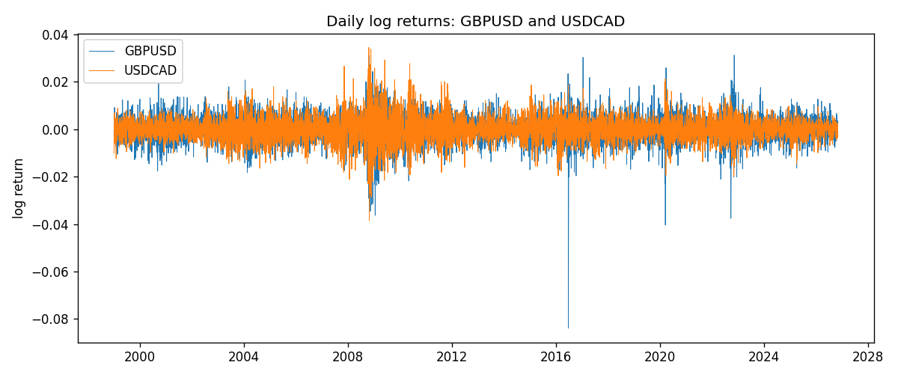
Log-return scatter
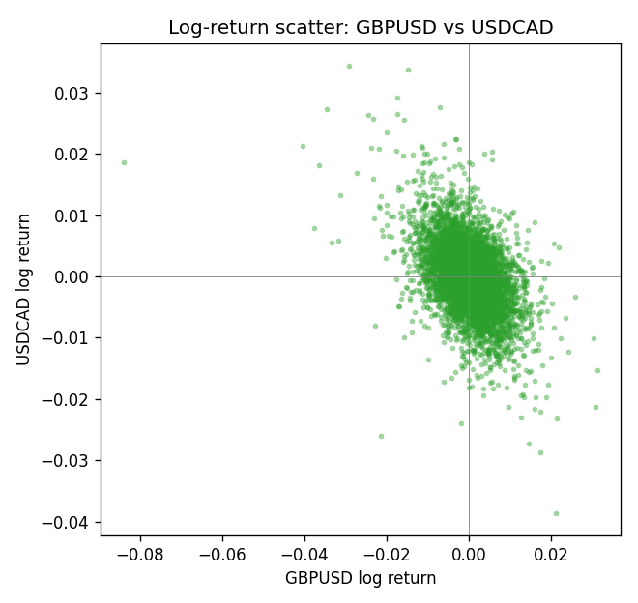

Data report
Every matched row that entered Kendall tau-b is stored in the sibling Excel workbook named GBPUSD-USDCAD_Kendall_D1.xlsx. That file is the complete data archive for redrawing charts. Embedding all rows as a Word table is impractical at this length; the Word file holds the column list, column summaries, and the first and last 15 matched rows.
Columns: time, GBPUSD_open, USDCAD_open, GBPUSD_high, USDCAD_high, GBPUSD_low, USDCAD_low, GBPUSD_close, USDCAD_close, GBPUSD_tick_volume, USDCAD_tick_volume, GBPUSD_spread, USDCAD_spread, GBPUSD_real_volume, USDCAD_real_volume, GBPUSD_log_return, USDCAD_log_return
Column summaries (matched calculation rows)
column | count | mean | std | min | 25% | 50% | 75% | max
GBPUSD_open | 7205 | 1.5161639 | 0.2182756 | 1.06854 | 1.32505 | 1.51142 | 1.63205 | 2.1066
USDCAD_open | 7205 | 1.2670469 | 0.16900802 | 0.9168 | 1.119 | 1.29857 | 1.3723 | 1.6183
GBPUSD_high | 7205 | 1.5224596 | 0.21884187 | 1.08366 | 1.32981 | 1.5182 | 1.6384 | 2.1161
USDCAD_high | 7205 | 1.2719479 | 0.16896591 | 0.9336 | 1.1234 | 1.30394 | 1.3769 | 1.619
GBPUSD_low | 7205 | 1.5098441 | 0.21750249 | 1.03518 | 1.31956 | 1.50336 | 1.62444 | 2.0983
USDCAD_low | 7205 | 1.2624879 | 0.16904619 | 0.9056 | 1.1144 | 1.29361 | 1.36793 | 1.6102
GBPUSD_close | 7205 | 1.5162333 | 0.21823062 | 1.06879 | 1.3252 | 1.5114 | 1.6322 | 2.1065
USDCAD_close | 7205 | 1.2670655 | 0.16898286 | 0.916 | 1.11851 | 1.29871 | 1.37253 | 1.6137
GBPUSD_tick_volume | 7205 | 94776.836 | 153518.92 | 62 | 9986 | 52867 | 91739 | 1273370
USDCAD_tick_volume | 7205 | 80835.261 | 147176.39 | 37 | 5509 | 40849 | 71515 | 1410818
GBPUSD_spread | 7205 | 26.978348 | 19.192834 | 0 | 11 | 20 | 50 | 50
USDCAD_spread | 7205 | 23.508952 | 18.282466 | 0 | 9 | 17 | 40 | 60
GBPUSD_real_volume | 7205 | 3.5541156e+09 | 8.441481e+10 | 0 | 0 | 0 | 0 | 2.4038164e+12
USDCAD_real_volume | 7205 | 1.8330194e+10 | 9.6578305e+10 | 0 | 0 | 0 | 0 | 2.5751613e+12
GBPUSD_log_return | 7205 | -2.188e-05 | 0.00563988 | -0.08388241 | -0.00312535 | 3.221e-05 | 0.0031749 | 0.03112653
USDCAD_log_return | 7205 | -1.219e-05 | 0.00514402 | -0.03859748 | -0.00283601 | 4.92e-05 | 0.00272763 | 0.03436319
First 15 matched rows (selected columns)
time | GBPUSD_close | USDCAD_close | GBPUSD_log_return | USDCAD_log_return | GBPUSD_tick_volume | USDCAD_tick_volume
1999-01-05 | 1.6547 | 1.5123 | -0.0028966287 | -0.010131666 | 4645 | 1345
1999-01-06 | 1.6537 | 1.5118 | -0.00060452184 | -0.0003306769 | 4729 | 1803
1999-01-07 | 1.6502 | 1.5141 | -0.002118709 | 0.0015202092 | 4858 | 1568
1999-01-08 | 1.6405 | 1.511 | -0.0058954193 | -0.0020495197 | 5354 | 914
1999-01-11 | 1.6312 | 1.5057 | -0.0056851331 | -0.0035137769 | 4080 | 953
1999-01-12 | 1.6349 | 1.5157 | 0.0022657001 | 0.0066194721 | 5001 | 1507
1999-01-13 | 1.6499 | 1.5226 | 0.0091330396 | 0.0045420214 | 5730 | 2141
1999-01-14 | 1.6531 | 1.5332 | 0.0019376331 | 0.0069376546 | 4902 | 1816
1999-01-15 | 1.6502 | 1.5245 | -0.0017558204 | -0.0056905671 | 6383 | 1897
1999-01-18 | 1.6522 | 1.526 | 0.0012112405 | 0.00098344542 | 4357 | 1091
1999-01-19 | 1.6553 | 1.5302 | 0.0018745281 | 0.002748513 | 4655 | 1634
1999-01-20 | 1.6472 | 1.5211 | -0.0049053846 | -0.0059646885 | 4502 | 1499
1999-01-21 | 1.6524 | 1.5146 | 0.0031518998 | -0.0042823796 | 4609 | 2007
1999-01-22 | 1.6565 | 1.5184 | 0.0024781662 | 0.0025057712 | 4230 | 1713
1999-01-25 | 1.6585 | 1.5197 | 0.0012066366 | 0.00085579808 | 3069 | 1471
Last 15 matched rows (selected columns)
time | GBPUSD_close | USDCAD_close | GBPUSD_log_return | USDCAD_log_return | GBPUSD_tick_volume | USDCAD_tick_volume
2026-10-13 | 1.32534 | 1.4214 | 0.0036434319 | -0.0046395653 | 53930 | 50947
2026-10-14 | 1.31884 | 1.42356 | -0.0049164679 | 0.0015184751 | 64640 | 56126
2026-10-15 | 1.32757 | 1.41843 | 0.0065976411 | -0.0036101503 | 80461 | 63096
2026-10-16 | 1.33257 | 1.41357 | 0.0037592051 | -0.0034322068 | 65988 | 54908
2026-10-19 | 1.33024 | 1.41091 | -0.0017500314 | -0.0018835331 | 56543 | 52155
2026-10-20 | 1.3377 | 1.40569 | 0.0055923442 | -0.0037066008 | 58955 | 54450
2026-10-21 | 1.33937 | 1.4045 | 0.0012476328 | -0.00084691787 | 55613 | 51369
2026-10-22 | 1.33967 | 1.40081 | 0.00022396082 | -0.0026307268 | 64255 | 58806
2026-10-23 | 1.33684 | 1.40085 | -0.0021146949 | 2.85545e-05 | 58068 | 50387
2026-10-26 | 1.33359 | 1.40093 | -0.0024340661 | 5.7106554e-05 | 56434 | 49601
2026-10-27 | 1.33044 | 1.40449 | -0.0023648393 | 0.0025379458 | 54846 | 49541
2026-10-28 | 1.33254 | 1.39911 | 0.0015771808 | -0.0038379274 | 61264 | 56077
2026-10-29 | 1.33733 | 1.39895 | 0.0035881935 | -0.00011436495 | 71194 | 59551
2026-10-30 | 1.33913 | 1.39751 | 0.0013450605 | -0.0010298736 | 70446 | 59373
2026-11-02 | 1.3406 | 1.39837 | 0.0010971256 | 0.00061519094 | 60471 | 53578

